|  |  |  |  |  |  |
| --- | --- | --- | --- | --- | --- |
| Date | 22-Aug-26 | | | Tester Name | Andrew McLaughlin |
| Environment | Penfax - Test | | | Login used |  |
| Operating System | Select OS | Version: | Update: | | |
| Software Used | Select Software | Version: | Update: | | |
| Select Software | Version: | Update: | | |
| Release version | 22.3.0 | | | | |
| Title | Death – Member Age 65 bridge reduction date correct PSSP | | | | |
| Test Type | Regression | | | | |
| Test Scenario | Death – Member Age 65 bridge reduction date correct PSSP | | | | |
|  |  | | | | |
| Expected Results |  | | | | |
| Pass/Fail | Pass | | | JIRA# | N/A |

Describe your steps with screenshots:

Member is with PSSP and has a bridge 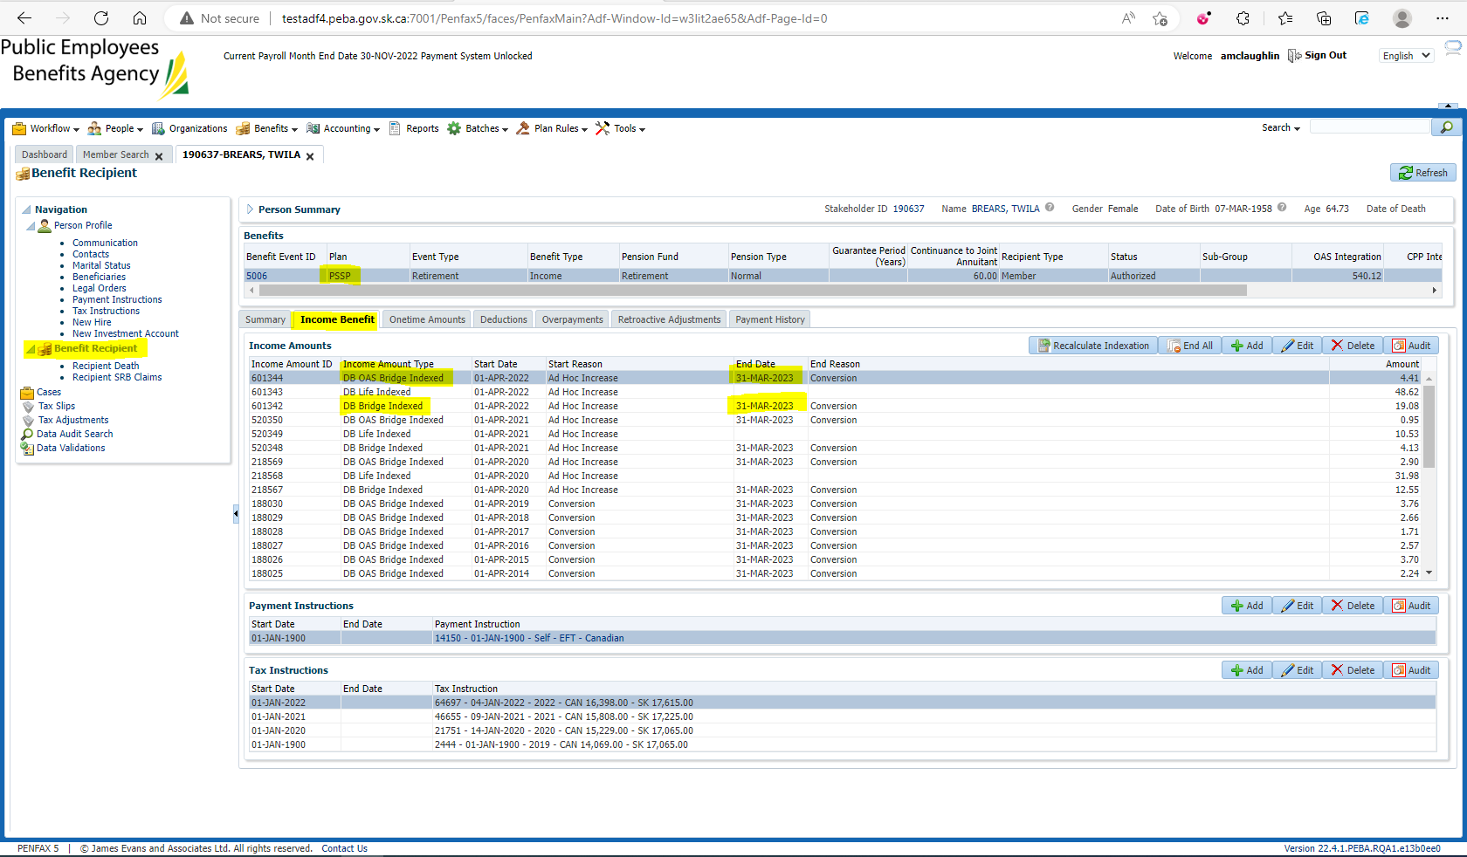

Pension amount is $3,991.20 with a 60% JA 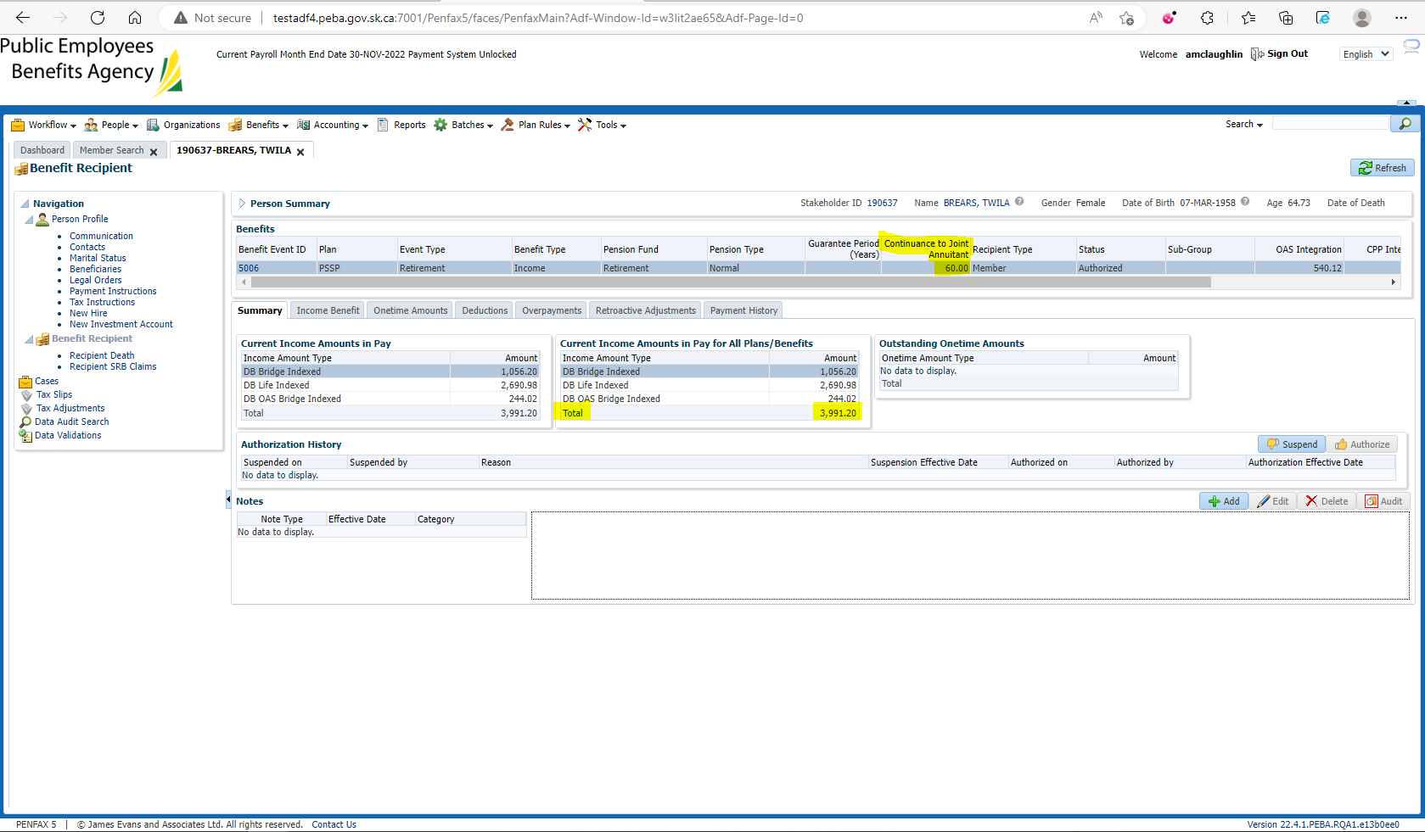

Enter Death Date 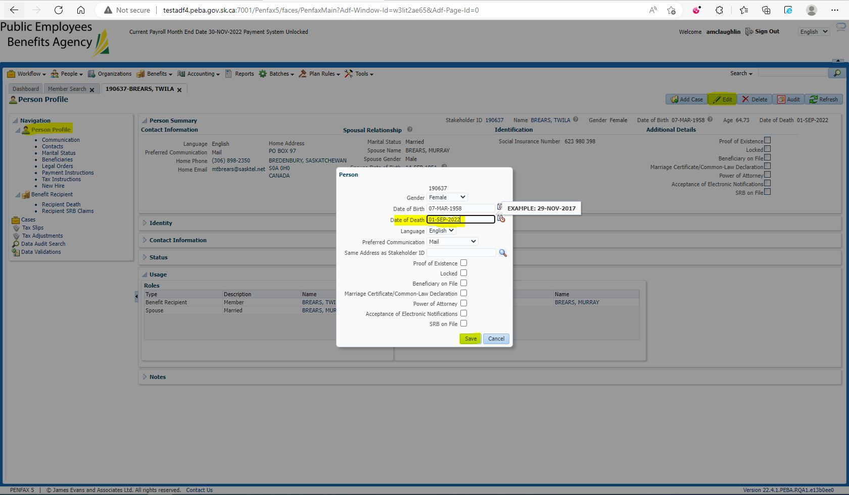

Add the spouse to the Benefit Recipients in the Benefit Event effective 1st day of month after death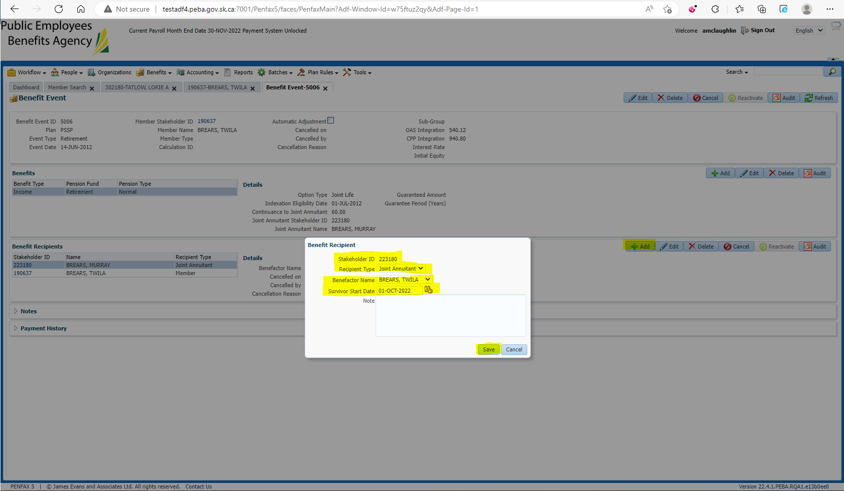

Open the Death Calc 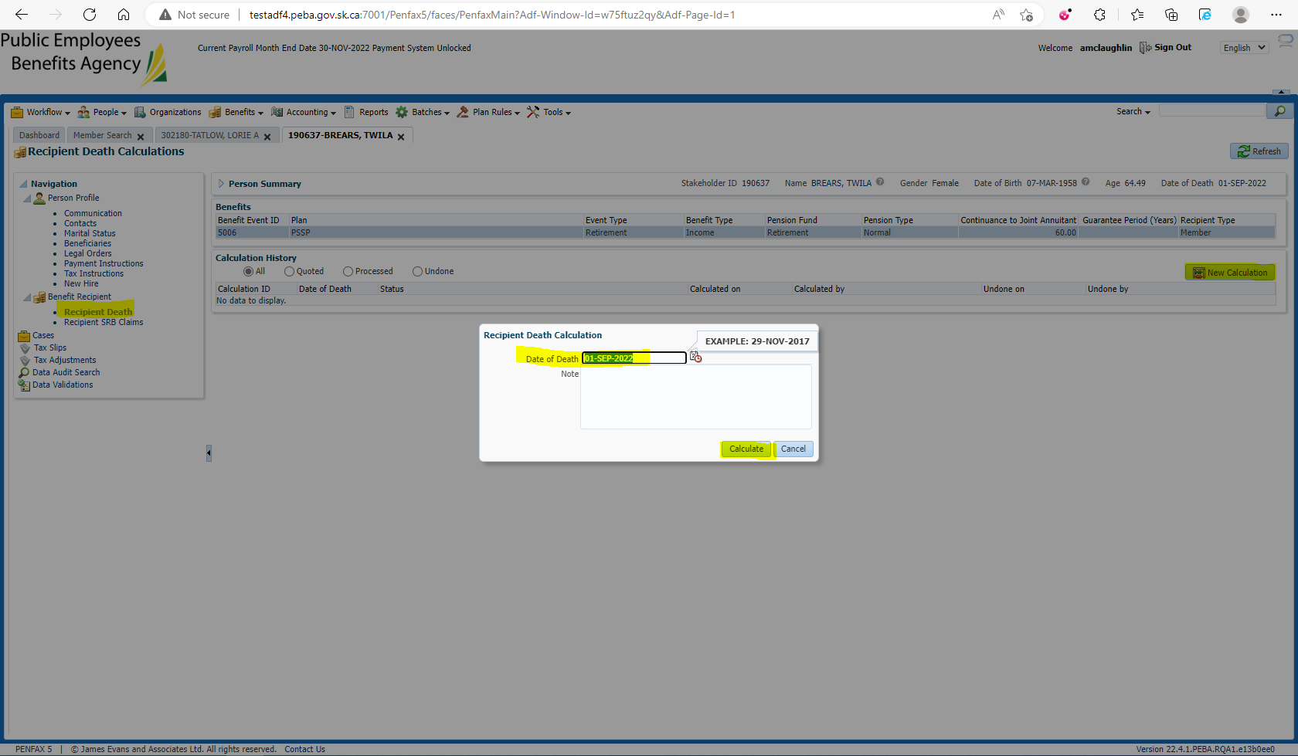

Process x2 and Process Recipient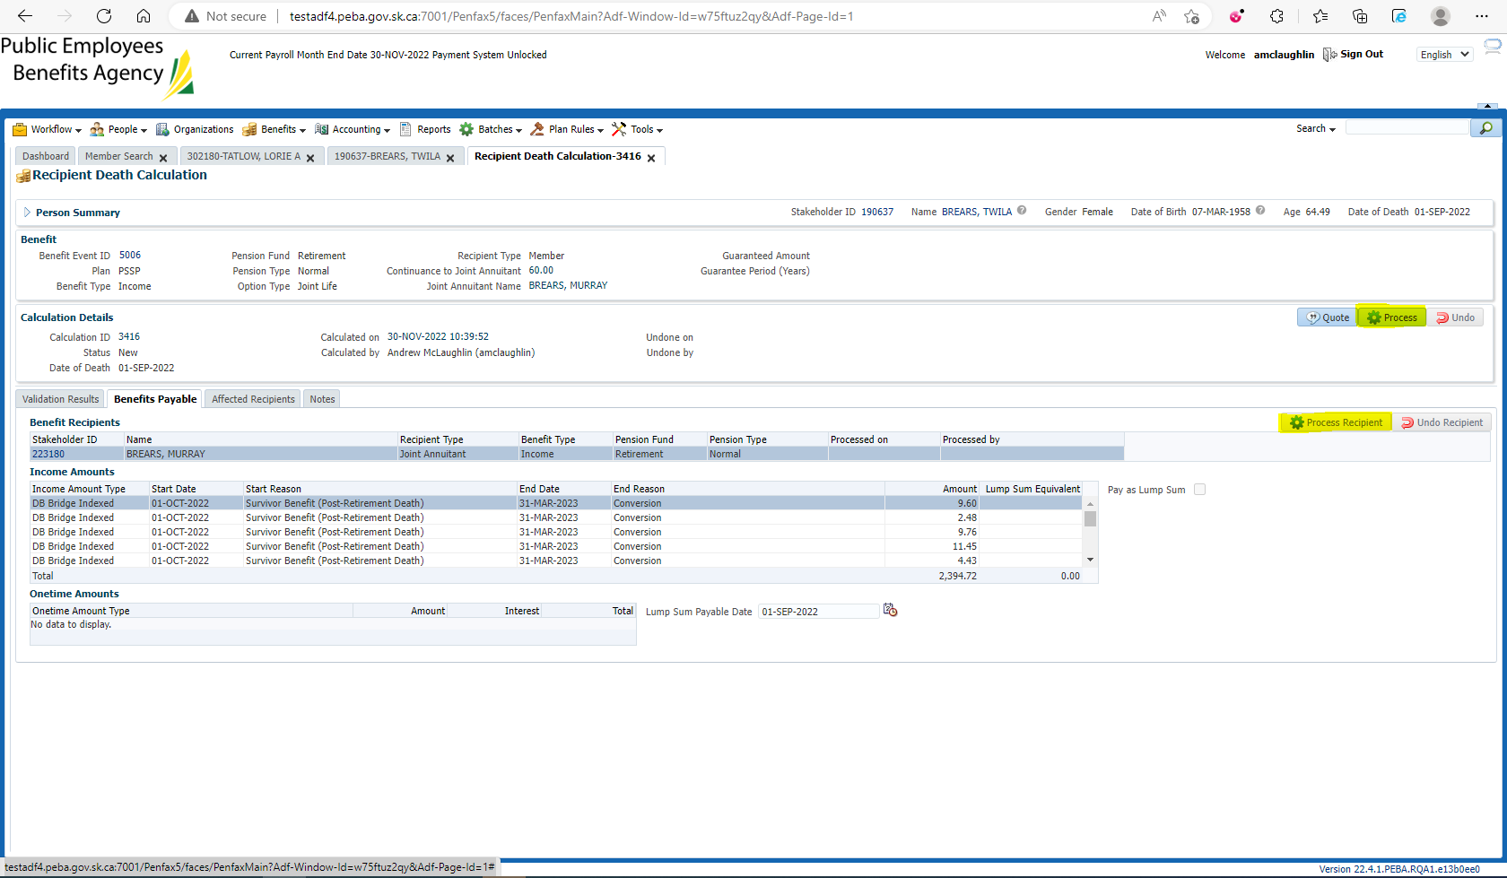

Verify under the spouse’s Benefit Recipient that the Bridge End Dates stay the same 